PROGRAMMING FUNDAMENTALS
FAROOQ AHMAD
17L-4407
EE-2A
LAB REPORT#4

INTORDUCTION
In this lab session we were introduced to the structures. A struct is a collection of fixed number of components, members, in which the members are accessed by name. The members may be different of data types. A struct is a user defined data type that requires the keyword struct followed by the name chosen for the struct. To access any member of a structure, we use the member access operator (.).

OBJECTIVE
The course learning objective of this lab session was the revision of file handling ( File input and output stream) and practice of structures.

PROCEDURE
The in lab tasks of this session included two exercises. In the first exercise, a text file of a list phone numbers was supposed to be read and the hyphen or the space was supposed to be removed and the phone numbers were supposed to be printed into another output text file.
Code
#include <iostream>
#include <fstream>
using namespace std;
struct phnum
{
char code[4];

char no[5];
};
void main()
{
phnum a[10];
ifstream sync;
sync.open("phnum.txt");
int i=0,j=0;
while(!sync.eof())
{
sync.getline(a[i].code,4,'-');
sync.getline(a[i].no,5,'\n');
i++;
}

ofstream print;
print.open("outfile.txt");
for(int i=0;i<10;i++)
{
print<<a[i].code<<a[j].no<<endl;
cout<<a[i].code<<a[j].no<<endl;
}
}

Output
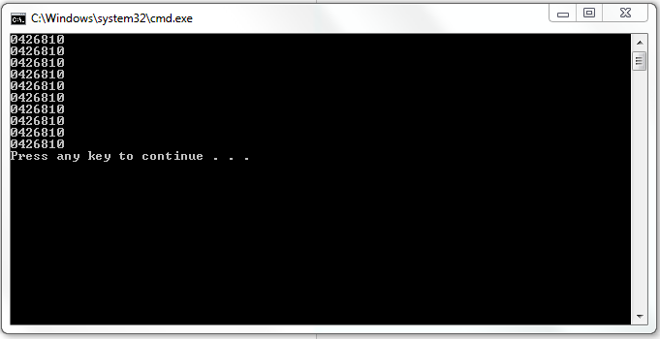
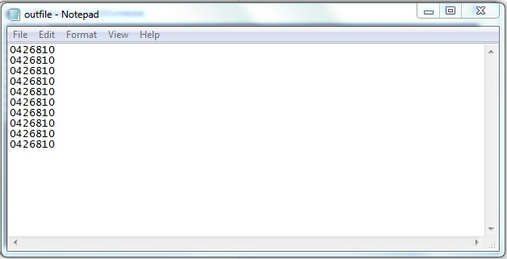

In the second exercise, we were supposed to define a struct with two components name and price. A breakfast menu was supposed to be created, displayed, menu items were supposed to be ordered and the bill was supposed to be printed including the tax.
#include<iostream>
using namespace std;
struct item
{
char name ;
double price;
};
void getdata(item menulist[6])
{
cout<<"Enter the Menu ..."<<endl;
cout<<"a for Bacon and Egg"<<endl;
cout<<"b for French Toast"<<endl;
cout<<"c for Fruit Baske "<<endl;
cout<<"d for Cereal"<<endl;
cout<<"e for Coffee"<<endl;
cout<<"f for Peanut butter:"<<endl;
for(int i=0; i<6; i++)
{
cout<<"Enter the alphabetic code of the product : ";
cin>>menulist[i].name;
cout<<"Enter the price of the product: ";
cin>>menulist[i].price;
}
}
void showmenu(item menulist[6])
{
cout<<"Menu ..."<<endl;
cout<<"sr. Name Price"<<endl;
for (int i=0; i<6; i++)
{
cout<<i+1<<". "<<menulist[i].name<<" "<<menulist[i].price<<endl;
}
cout<<"Enter -1 to exit ordering"<<endl;
}
void printcheck(item menulist[])
{
int option=0;
double total=0;
double bill=0;
int *order=new int[100];
int orders=0;
int i=0;
while(option!=-1)
{
cout<<"Enter order number : ";
cin>>option;
if (option!=-1)
{
order[i]=option-1;
i++;
total= total+ menulist[option-1].price;
bill=(total*.05)+total;
orders++;
}
}

cout<<"Your order is :"<<endl;
for(int j=0; j<orders; j++)
{
cout<<j+1<<". "<<menulist[order[j]].name<<" "<<menulist[order[j]].price<<endl;
}
cout<<"inclusive of tax of 5%"<<endl;
cout<<"check = "<<bill<<endl;
}
void main ()
{

item menulist[6];
getdata(menulist);
showmenu(menulist);
printcheck(menulist);

}
Output
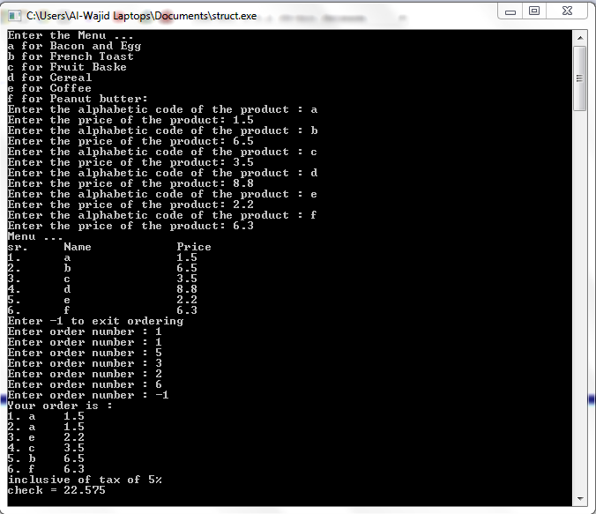

ISSUES
Some issues were faced while doing the exercise 1 for removing the hyphen and time could not be managed because of the lengthy exercise 2.

APPLICATION
This lab session is applicable for defining and using structures.

CONCLUSION
After this lab session we were able to use file handling and structures.

POST LAB
TicTacToe

#include <iostream>

using namespace std;

struct TicTacToe

{

char board[3][3];

char player ;

char winer ;

int row ;

int col ;

void printBoard();

void move();

bool moveValid();

bool win();

};

int main()

{

cout << "Mark your position" << endl;

TicTacToe t;

t.board[3][3]= (('1','2','3'),('4','5','6'),('7','8','9'));

t.player = 'X';

t.winer = ' ';

t.row = 0;

t.col = 0;

for (int i=0; i<9; i++){

t.printBoard();

t.move();

if (t.win()){

t.winer=t.player;

break;

}

else{

if (t.player == 'X'){

t.player = 'O';

}

else if (t.player == 'O'){

t.player = 'X';

}

}

}

if (t.winer == ' '){

cout <<"The Match is a Tie";

}else{

cout << t.winer << " is winer";

}

return 0;

}

void TicTacToe:: printBoard()

{

for (int i=0;i<3;i++)

{

for (int j=0;j<3;j++)

{

cout << board[i][j] <<" ";

}

cout <<endl;

}

}

void TicTacToe:: move()

{

cout << "Player : "<<player<<endl;

do

{

cout<<"Enter The Row : ";

cin>>row;

cout<<"Enter The Col : ";

cin>>col;

} while (!moveValid());

}

bool TicTacToe:: moveValid()

{

if (row == 1 || row == 2 || row == 3)

{

if (col == 1 || col == 2 || col == 3)

{

if (board[row-1][col-1]!='X' && board[row-1][col-1]!='O')

{

board[row-1][col-1]=player;

return true;

}

else{

cout <<"The Place is Already Occupied \n Try Again \n";

return false;

}

}

else{

cout<<"The Column Must Be 1, 2 or 3 \n Try Again \n";

return false;

}

}

else {

cout<<"The Row Must Be 1, 2 or 3 \n Try Again \n";

return false;

}

}

bool TicTacToe:: win()

{

for (int i=0; i<3; i++){

if (board[i][0] == board[i][1] && board[i][1] == board[i][2] )

return true;

}

for (int i=0; i<3; i++){

if (board[0][i] == board[1][i] && board[1][i] == board[2][i] )

return true;

}

if (board[0][0] == board[1][1] && board[1][1] == board[2][2] )

return true;

if (board[2][0] == board[1][1] && board[1][1] == board[0][2] )

return true;

return false;

cout<<endl;

}

